Weston Wrzesinski
IFT458
Project Deliverable 8
4/20/2020

The purpose of this project was to setup the REST framework for HTTP requests to the website. The first step included setting up the serializer to convert the information from each of the SynerD tables to JSON. The second part was setting up the urls.py, views.py, and admin.py files to point to the tables. Finally, we tested the GET request through the interactive console and by viewing them through the admin console through Django in a web browser.
This project went surprisingly smooth for me. I was able to get everything up and running properly with only a couple minor errors that were typo related.

To run this:
1. cd to the directory where the script files are contained (PD6 in this case, even though it’s for PD8)
2. Use python3 manage.py runserver to start the Django server.
3. View the API listings at http://127.0.0.1:8000
4. Submit REST requests through the interactive console to any of the tables listed in SynerD.

In conclusion, I am getting the hang of Django a bit better now. This project was great to see how the REST requests work and how to set them up, as well as getting the serializer set up. As I said last project, the videos provided on the class website have been very helpful in the context of our project. Looking forward to the next project.

Some screenshots:

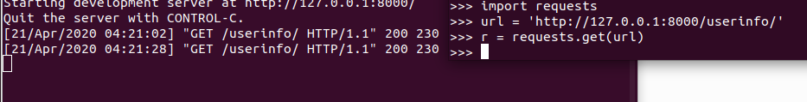
A GET request from the interactive console and the response from the server console window:
